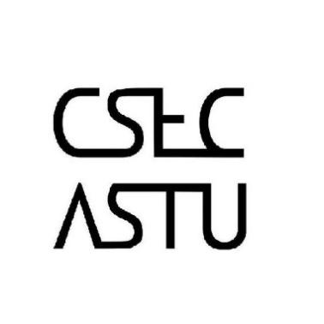

For all Students who want to join our development division to work on various projects, please register for the entrance Hackathon at our Lab or via the Google forms link on our Telegram channel or Facebook page

**Registration place** – B-508 R-9 or via the links on our social media accounts (***@CSEC_ASTU***– on Telegram)

**Registration deadline** – Monday, November 12, 2018

**Follow US on social Media for more updates…**

